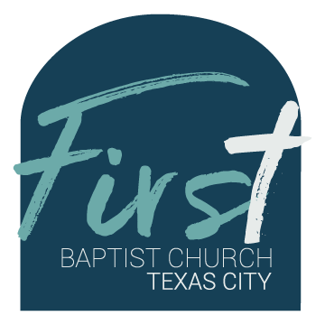
First Baptist Church Safety Team
Training Bulletin #11

Updating Your Church Center App Profile

It has been noted that some members of the Safety Team (and other church app groups) are not receiving notifications. We will go over, step-by-step, how to make sure your profile is complete and you are receiving notifications.

- Open the Church Center application.
- In the top right corner of the home screen, you should see your profile icon (either with your picture if you have uploaded one, or your first and last initials, i.e. John Smith would be JS). Click on the icon to take you to the “Me” page.
- Click on “My Profile & Settings” or the arrow to the right. This will open your Profile and Settings and you will see “Contact & Profile Information,” “Household,” and “Directory profile.”
- Click on “Contact & Profile Information.” This will take you to your phone and email information. Make sure that all of your information is complete. Then click “Update.” When complete, click the “X” next to “Edit Profile.”
- Click “Directory Profile” and update your information as you did in the previous steps.
- Under the “Profile and Settings” tab, click the “Notifications” link. This will open up separate tabs “Team and schedule,” “Giving,” and “Groups.” Click on the “Groups” link and click “Safety Team” and make sure that the “News resources” and “Event reminders” switches on the right are turned on (will appear green).
- Back out of each of the tabs or click the “Home” icon on the bottom left. You should now receive all notifications.

